

Figure : "What's your largest remaining goal in life?" "I'm just a tourist in this world. I'm not trying to affect anything."

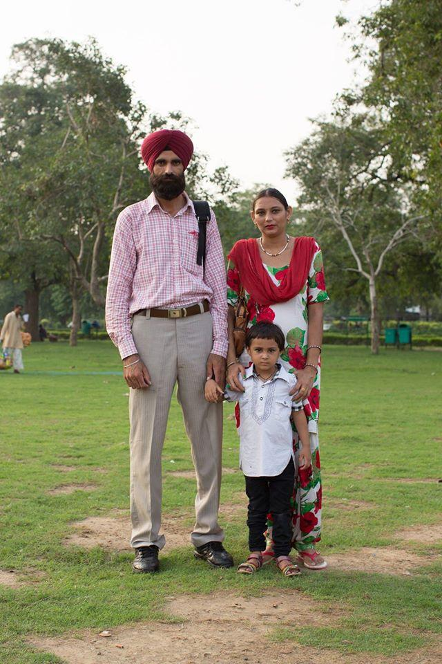

Figure 2: "What’s your biggest dream for your child?" "We’ll let him dream for himself." (New Delhi, India, September 2014)

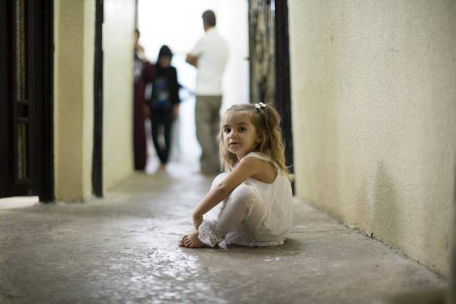

Figure : “She speaks more languages than anyone in the family. Because she plays with all the children in the street.” (Erbil, Iraq, August 2014)



Figure : ‘What inspires you?’ ‘Colors, flowers, and picnics’

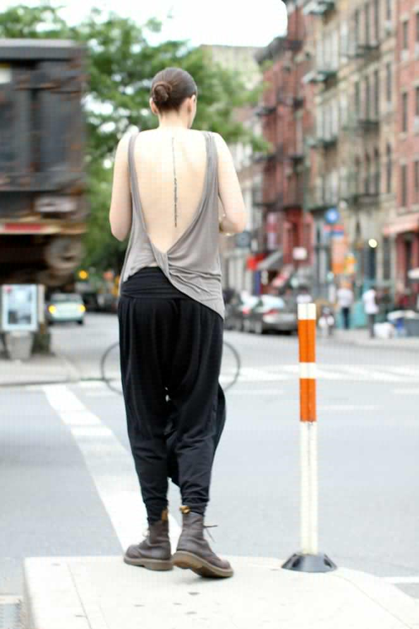

Figure : It reads: ‘When birds look into houses, what impossible worlds they see.’

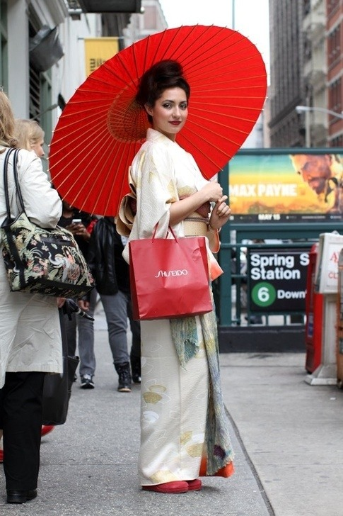

Figure : Make sure you can see the bag' 'Oh, I didn't realise you were advertising something.' 'Isn't everything beautiful advertising something?'

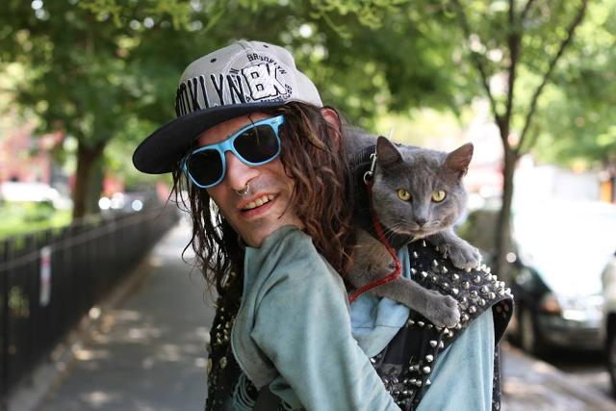

Figure : "I found him in the trash. I named him Shadow because he followed me everywhere." (New York City, July 2014)



Figure : "I did 8.5 years on an attempted murder charge." "What happened?" "Some thirty-year-old dude kept harassing my twelve-year-old sister. He’d wait outside her school and invite her to parties. So I tried to kill him." (New York City, June 2014)

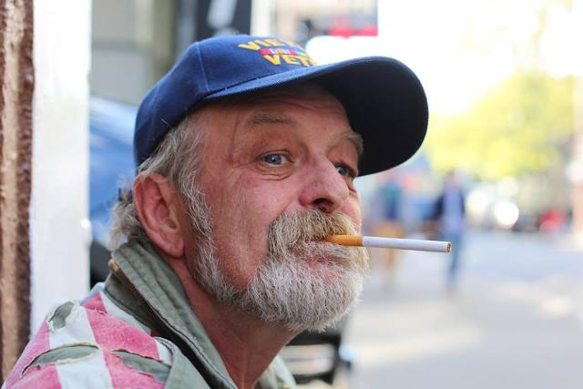

Figure : "Saddest moment? How am I supposed to choose between losing my parents and seeing my friends die in Vietnam? I don’t categorize those things. Listen, a person is like a rubber band ball. We’ve all got a lot of bad rubber bands, and a lot of good rubber, and they’re all wrapped up together. And you’ve got to have both types of bands or your rubber band ball ain’t gonna bounce. And no use trying to untangle them. You know what I’m saying?" (New York City, May 2014)”



Figure : "His owner told me that according to a Native American myth, dogs with different colored eyes can see both heaven and earth." (New York City, April 2014)

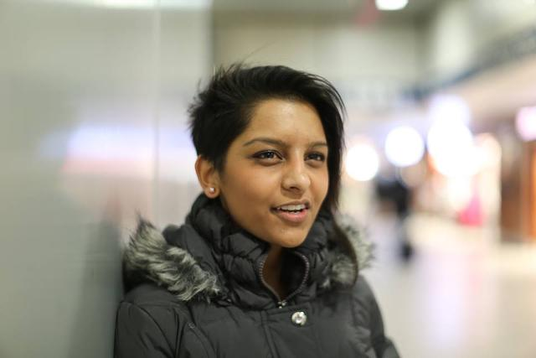

Figure : "A co-worker asked for my number the other day. My friends overheard and said: ‘He must have a thing for Indians.’ I was like, ‘Or maybe I’m just really f\*\*\*ing cool.’" (New York City, March 2014)

Denotation: Figure 11 captures an Indian girl, in a black furry jacket with an unconventional haircut, ear piercings and giving the ‘what the hell!’ look to the camera, which is clearly justified by the caption. Connotation: This photograph majorly emphasizes on the societal stereotypes that are generally let go off easily, which in this case, the girl did not. She answered back pretty coolly after being stereotypes as being an Indian and hence getting asked out for a date by someone who must be having a thing only for Indians. The courage, confidence and strength the girl possesses is clearly visible on her face and personality and with her look saying – ‘You better not mess with me!’ – nobody would really dare to do so.

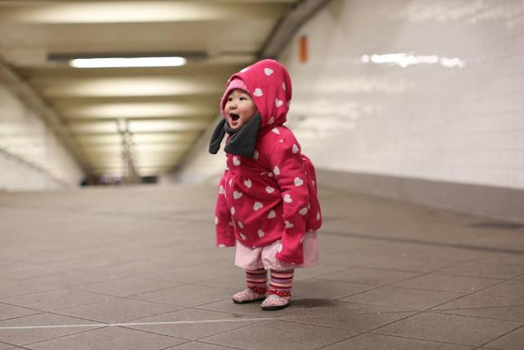

Figure : (New York City, February 2014)

Denotation: Figure 12 captures a cute little baby dressed in all pink laughing with all her might. Connotation: This photograph is something that is the most-basic way of capturing images and captioning them, by HONY. This is how he started and got his outreach which enabled him to grow further and further. It’s just a happy photograph which resonates happiness into everybody who looks at it, and brings a smile to their faces.

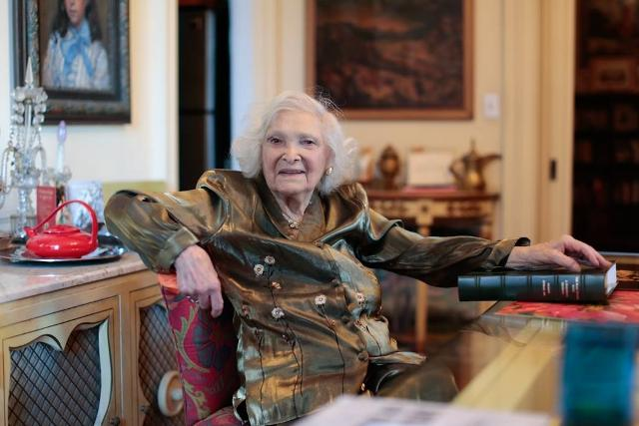

Figure : "When I was 19, my girlfriend and I were going to study in Paris. Our boyfriends came to the docks to see us off. Right as we were getting on the ship, my friend’s boyfriend said to her: ‘If you go, I won’t wait for you.’ So she turned around and decided to stay. My fiancé saw this and told me: ‘I won’t wait for you either.’ I said: ‘Don’t!’” (New York City, January 2014)

Denotation: Figure 13 captures an old lady, probably in her late 50s, sitting on a table with a book in front of her which she is holding with her left hand. She is wearing a jacket and sitting with her right hand on the back rest of her chair. The ambience looks like a royal antique one, which probably could be a library. Connotation: Her smile tells us about her fun personality and daring nature which is emphasized upon by the answer she gives. She believes in herself, and will never compromise for anybody. She can be truly called a self independent woman who does not care about what others think, unless she is on the right track, everything will eventually fall into place. She believes in growing as a person is important and nobody should give up on their dreams for others. This is a life lesson major chunk of teenagers require, as they are the ones who get influenced very easily.

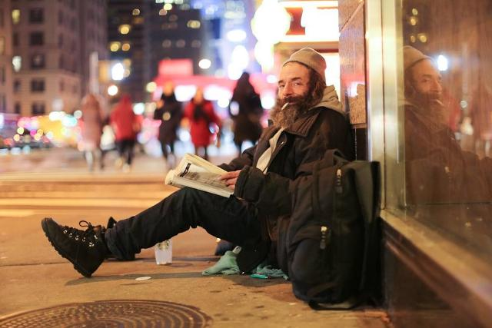

Figure : "I’ve got a whole stack of books in my cart. Most of them are advance copies. I know a place where they get thrown out." “How many books have you read?” “Thousands.” “So why are you homeless?” “I’ve tried to work a job a bunch of times. But then I get sad, and then I get high, and things fall apart.” (New York City, December 2013)

Denotation: Figure 14 shows a middle aged man, with unshaved facial hair and long hair dressed in black with a black backpack. He is reading a book sitting on the side of the street which hints at him being homeless. He is holding a cigarette in between his lips as he poses for the photograph. We can see a busy city life in the background and a little mess created around him. Connotation: The man is least bothered by the hustling and bustling of the city life around him, as he is engrossed in his own world while reading his book. He has read over thousands of books but is still homeless, as he can not continue with any job for long as it makes him sad after a point, every time. This is ugly reality of our society, where people are unable to live their lived the way they want, by doing what they want, just because of the standards set by the society. It is difficult for a person to come up unconventionally, or by being different than the others.

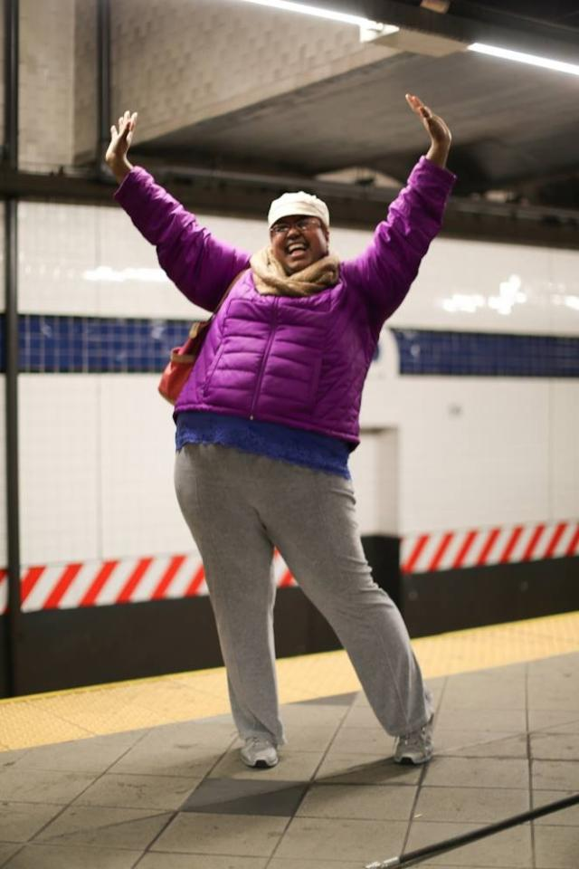

Figure : "I used to be a preschool teacher, but I got fired." “What happened?” “Well, I decided that I wanted to have a socially conscious class. So we learned about apartheid in South Africa. Then we learned about homelessness. Then we made Mother’s Day cards for Trayvon Martin’s mom. And I think the principal decided that it was too much for three- and four-year-olds, because she told me I wasn’t a ‘good fit.’ But honestly, I was just shining too bright for them. And now she’s going to see me on Humans of New York, and she’ll be sorry!” (New York City, November 2013)

Denotation: Figure 15 shows a happy middle aged woman who has recently been fired from her job as a school teacher as she wanted to have a socially conscious class who would know about the realities of the world and be empathetic towards it. This idea of hers did not really match with that of most around her, hence she was asked to leave. Connotation: Despite of being fired recently from her job, she has not lost hope, and still is a happy soul as she truly believes in herself and her idea which are not wrong at all. It is difficult to make others differentiate between the socially right and superficially right matters. But, her hope and positive-ness might someday make her successful in doing so. It is rare that somebody has such a happy-go-lucky personality, and knows how to deal with every atrocity with a smile on their face.

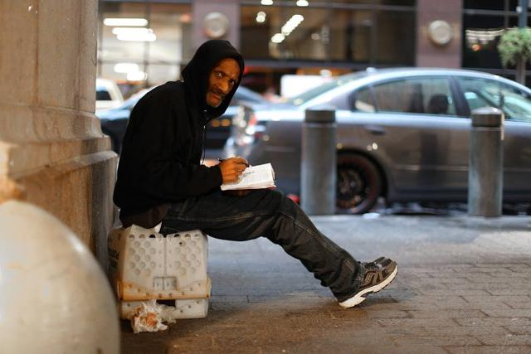

Figure : "My daughter lives in Pennsylvania. She’s working at a nursing home and studying to be an accountant. She’s my pride and joy." "Does she know you’re homeless?" "No, she’s got enough to worry about. I just tell her that I’m retired." (New York City, October 2013)

Denotation: Figure 16 shows a man sitting on the roadside in all black, he is homeless and has a diary with him where he was writing something before being photographed. He tells the photographer how her daughter is unaware about him being homeless, as he doesn’t want to add to her troubles. Connotation: He is an ideal example of any loving father who would never want to be a burden on their kids, as they love them so much. He wants her to succeed in life and achieve her goals, even though he might have to suffer for it. As he believes in her and is courageous enough to do so. He is immensely proud of her and she is her happiness, and he would not in the world want her to be hurt at any cost, hence he is hiding the fact of him being homeless from her. We can figure that he is a calm, and kind man who believes in the good in this world.